The Following is for Regulated Azure Subscriptions

8. In Machine Learning Studio, open the Notebooks blade if your screen presents the following use these instructions below

9. Goto Compute , ensure the VM is running and launch VS Code Web

10. Allow Extension to use Remote and Authenticate

11. Expand Users and Trust the Authors dialog box

12. Richt Click on Users and Choose Upload:

13. upload the following from the workshop ***files*** folder

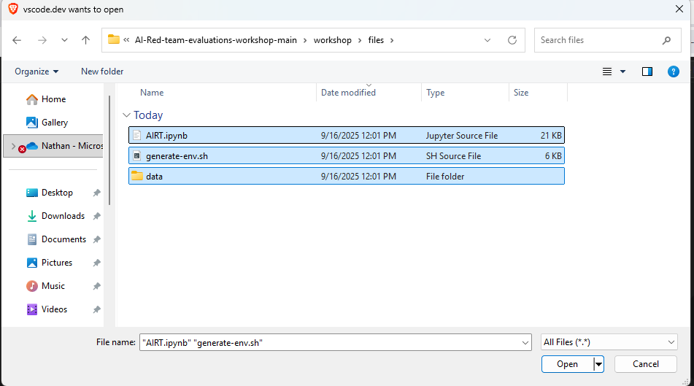

14. Create a data directory and upload the prompts.json

15. Click on AIRT.ipynb and select kernel Azure ML Compute instance (compute-xxxxxx) and choose ipkernel

[Proceed to Module 0:](https://github.com/swiftsolves-msft/AI-Red-Teaming-Workshop/blob/main/workshop/Module%200%20-%20Deploy%20Model%20and%20Configure%20Filters.md)